Tool Setup: IDEs and Source Control

Before we get started programming, we need to set up our development environment. If you're using a school computer lab, the machines may already have Visual Studio and Git on them. If you'd like to program at home, you can install free tools to use.

IDE – Integrated Development Environment

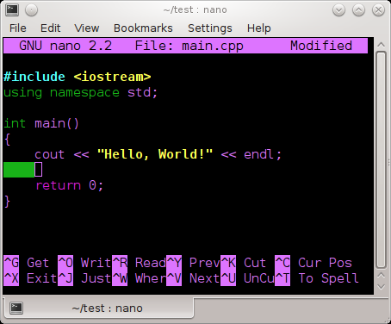  We are going to start out by using an IDE to write our C++ code, even though using an IDE isn't required to write a  C++ program.  You could write a program with a normal text editor (think: Notepad, but don't use Notepad – it is terrible.),  and then build your program with a compiler (this builds it into an executable file.) | Writing a simple C++ program with nano, a Linux-based text editor.
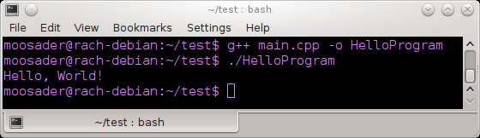  This could be useful if you're on a machine that doesn't have a Graphical User Interface, or tunneling to a server with ssh or PuTTY. (But, that's another class!) | Building a simple C++ program with g++ and running it in a terminal.

An IDE is an Integrated Development Environment, which generally means your fancy text editor (with syntax highlighting!), debugging tools, and it usually has the build/compile option available from within the program, so you don't have to compile externally.

Note that the IDE is not the compiler! The compiler is a separate piece, and many IDEs let you use any compiler you want. Additionally, it (generally) should not matter which compiler you use for writing C++ programs – C++ is a standardized language.  Some compilers might not support the newest C++ standards and some might, but for the most part we will be covering C++98. | Names of some compilers...  - CL (Used in Visual Studio)  - gcc, g++ (For Linux)  - mingw (Windows version of gcc)  - Clang

Visual Studio Community  https://www.visualstudio.com/en-us/products/visual-studio-express-vs.aspx  Platforms: Windows  Visual Studio Community is the free version of visual studio, meant for “individual developers, open source projects, academic research, education, and small professional teams.” (So, basically, don't run your gigantic corporation with VS Community) | Code::Blocks  http://codeblocks.org/  Platforms: Windows Linux OSX  Code::Blocks is an open source IDE, available on multiple platforms. You can use multiple compilers with it.  If you're running it on Windows you should download the version with mingw  (Downloads > Binaries >  codeblocks-13.12mingw-setup.exe )
Eclipse CDT  https://eclipse.org/cdt/  Platforms: Windows Linux OSX  Eclipse is more traditionally used for Java, but there is also a flavor that supports C++. This is another decent choice if you want an IDE on multiple platforms. | Xcode  https://developer.apple.com/xcode/  Platforms: OSX  Xcode is Apple's IDE for using their languages, but also supports languages like C++.

Sample Program
Got something downloaded? Let's write a quick program to make sure everything is in working order!
We will step through setting up the IDE below, but for now here's the sample code we will use:
#include <iostream>
int main()
{
std::cout << "hello!" << std::endl;
return 0;
}

We will go over the basics of C++ later, but here's a quick rundown:
- #include is how we tell our program that we're using a Library, where a Library is essentially a bunch of code that you or somebody else has already written, set up to be reused across multiple programs.
- iostream is part of C++ standard library – it allows you to use Input and Output as a stream. (We will learn more about what “Streams” are later!)
- int main() is our program entry-point. Every program begins with the main function.
  - int means Integer – our main program will be required to return an integer at the end.
  - The return 0; is doing this – it is saying that there were no problems. We used to return different error codes when certain things went wrong (and 0 means nothing went wrong), but there are better ways to handle errors these days.
- std::cout is short for standard console output – this is how we tell the program that we're going to write some text to the screen.
- std::endl is short for standard end line – You can also use “\n” within the quotation marks, or you can throw an endl in there for a new line.

Visual Studio Community

Code::Blocks
- Go to File > New > Project...
- Select Empty project and hit Go.
- Enter a Project title, and browse to a Folder to create project in. The Project filename will be auto-populated, but you can change it if you'd like.
Code::Blocks will automatically add a sub-folder with your project's name.
Click Next >
- The defaults for Debug and Release are fine. Click Finish.
- Go to File > New > Empty file (CTRL+SHIFT+N). It will ask whether to add it to the active project – select Yes. Save the file as main.cpp (or anything.cpp).
- It will ask whether this file is for both Release and Debug. Have them both checked and click OK.
- Paste the sample code into your main.cpp file.
- Go to Build > Build and run.
- It should build, and a console window should pop up:
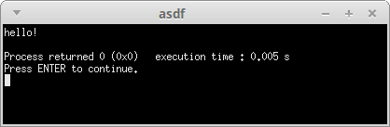
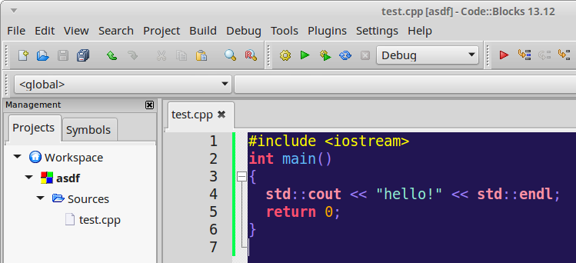

Eclipse

XCode

Source Control
Now that you have an IDE set up, we need to talk a little bit about Source Control (aka Revision Control, aka Version Control...)
Almost any software or web development shop that you will work at will use Source Control (and if they don't, you should not take that job!), but Source Control can also be useful for a single-person team.
Source control lets you...
- Back up your work at regular intervals to a server
- Keep track of the changes you've made to each file over time.
- Restore backups at any point in history, for all files or one specific file.
- Access your code from multiple machines (if the server is online).
- Help you work with other programmers – merge code, view changes each person has made, etc.
- Build a public portfolio of your work, which potential employers like to see!

Some common Source Control tools are Git, Mercurial, SVN, and TFS.
There are also various source hosting websites out there, many that let you store your code for free, such as Bitbucket, GitHub, SourceForge, and Codeplex.
We will be using GitHub.

Hello, GitHub!
GitHub is free for open source projects and student use. If you want to host code privately, you would have to pay (this is why I use Bitbucket for my private projects and GitHub for my open source projects.)
GitHub also has its own software to make using Source Control easier on Windows and OSX, though we will also cover how to use Git through the command line.

Register an Account
Go to https://github.com/ and register an account with your student email address. Note that you can change your username at any time.

Download GitHub Desktop
You can download GitHub Desktop from: https://desktop.github.com/
This should also install the standard Git tools (Git GUI and Git Bash), which are available at: https://git-scm.com/ (You don't need to download this if you're instlaling GitHub Desktop).

